**Press Release**

**IFFCO Group partners with Tetra Pak to Ensure Long-term Sustainable Production and Packaging of Culinary Creams in Saudi Arabia**

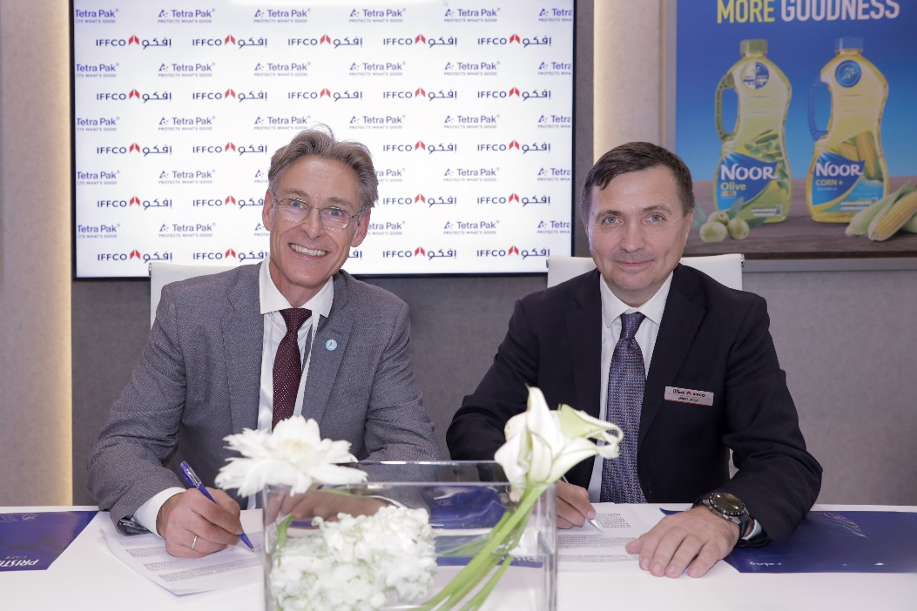

**DUBAI, UAE, 13 December, 2023**: IFFCO Group, as part of its ESG-based strategic plans in the Kingdom of Saudi Arabia, has signed an MoU with Tetra Pak, the world's leading food processing and packaging solutions company, designed to drive the momentum of sustainability initiatives within the group’s manufacturing facilities.

This groundbreaking collaboration between IFFCO, the UAE-based multinational FMCG group, and the renowned multinational entrepreneurial organization, Tetra Pak, cements a strategic alliance that supports the implementation of global standards in state-of-the-art practices and technologies aimed at minimizing the group’s environmental impact.

IFFCO is expanding its operations in the Kingdom by building a state-of-the-art factory equipped with the latest technology in order to locally produce sustainable, high quality and delicious products while adding value to the Saudi Arabian economy and contributing to reducing waste, lowering emissions and prioritising green industry protocols. The factory will initially focus on producing culinary creams, and has formalized the MoU with Tetra Pak to maximize efficiency without compromising on quality or food safety.

**Rizwan Ahmed, the Executive Director of IFFCO Group**, explained that the KSA facility comes as a natural follow up to the group’s embedded ESG ethos, which is the principle driving force behind the group’s journey towards sustainability, saying: “IFFCO has since the very beginning, committed to a mission to manufacturing and marketing a well-integrated portfolio of FMCG food products that satisfy taste, quality and consumer demand without undermining our ethical values and commitments to eco-awareness throughout all processes and practices.

“By working with the global expert Tetra Pak, we are actively contributing to ensuring sustainability at the plant, enhancing reliability, package recyclability, energy efficiency, and waste reduction, employing local skilled personnel and underpinning the country's economic growth and future ambitions while strengthening IFFCO’s standing in the region as an advocate for change, reducing reliance on fossil fuels, and lowering our carbon footprint.”

**Niels Hougaard, Managing Director at Tetra Pak Arabia Area** said: "We are thrilled to partner with IFFCO in this impactful project in Saudi Arabia, reflecting our commitment to protecting people, food, and the planet. Together, we introduce advanced equipment and processes that reduce waste, enhance recyclability, and lower CO2 emissions. Our innovation prioritizes water efficiency, recycling and reusing processed water, with state-of-the-art and energy-efficient equipment. Every package tells a story, and we eagerly support IFFCO's leading role in the GCC.”

IFFCO has implemented a robust range of sustainability targeting measures that are based on a holistic approach to reducing the group’s environmental footprint. The group also establishes partnerships with local suppliers and third-party entities, encouraging them to also adopt sustainable practices.

IFFCO group has recently released its Environment, Sustainability and Governance (ESG) report, which outlines its commitment to sustainability goals, and puts sustainable practices in place across its operations and value chains, an important step in adopting changes to the food system that are genuinely sustainable, through an agenda of “Investing in the Future” to help in reducing greenhouse gas emissions, enhancing endeavours to work towards net zero targets, decreasing waste generation, using packaging with a lower environmental impact, and addressing water scarcity.

**-ENDS-**

**For more information, please visit:**

[Iffco.com](https://iffco.com/) | [Facebook](https://www.facebook.com/IFFCO) | [X](https://twitter.com/IFFCOGROUP) | [Instagram](https://www.instagram.com/iffco_group/) | [LinkedIn](https://www.linkedin.com/company/iffco/) | [YouTube](https://www.youtube.com/@iffco_group) | [TikTok](https://www.tiktok.com/@iffcogroup)

**About IFFCO Group:**

Established in 1975, IFFCO is a multinational group headquartered in the UAE. Its leading FMCG brands, including London Dairy, Tiffany, Noor, Rahma, Al Baker, Hayat and Savannah, and a portfolio of industry solutions and services enrich the lives of millions of consumers and customers globally. The company has 95 operations in 50 Countries, supported by over 15,000 employees, and its 80+ brands are available in over 100 countries.

**For media enquiries, please contact:**

Rana Abu Atta

Head of Corporate Communications

[raatta@iffco.com](mailto:raatta@iffco.com)

Sana Yamlikha

Associate Manager – Corporate Communications

[syamlikha@iffco.com](mailto:syamlikha@iffco.com)

**ABOUT TETRA PAK**

Tetra Pak is a world leading food processing and packaging solutions company. Working closely with our customers and suppliers, we provide safe, innovative and environmentally sound products that each day meet the needs of hundreds of millions of people in more than 160 countries. With more than 25,000 employees around the world, we believe in responsible industry leadership and a sustainable approach to business.

Our promise, “PROTECTS WHAT’S GOOD™," reflects our vision to commit to making food safe and available, everywhere.

More information about Tetra Pak is available at [www.tetrapak.com](http://www.tetrapak.com/)

  [**youtube.com/user/tetrapak**](https://www.youtube.com/user/tetrapak)

 **@tetrapak**

 [**https://www.linkedin.com/company/tetra-pak/**](https://www.linkedin.com/company/tetra-pak/)

**MEDIA CONTACT:**

**Hanae Ouakrime, External Communications Consultant**

[**Hanae.ouakrime@tetrapak.com**](mailto:Hanae.ouakrime@tetrapak.com)**, +971528938805**